ATTENTION SCIENCE UNDERGRADS:

Have you considered majoring in Molecular Biology & Biochemistry?

Come see what MBB has to offer!



What? MBB Open House

Why?

* Free food and refreshments
* Highlights of our most popular courses
* Tours our teaching and research labs
* Hear about our joint majors, research opportunities and careers in the field
* Talk to MBB undergraduates, grad students, famous alumni, and instructors
* Ask questions of the MBB Undergraduate Advisor and the Co-op Advisors

When?

Thursday, March 2, 2:30-4:30 PM

Where?

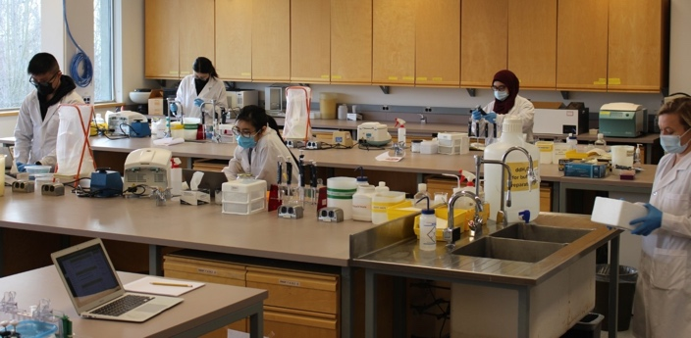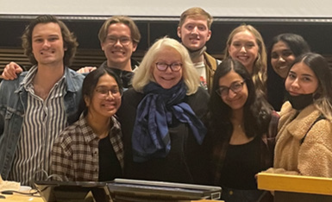

SSB 8000

(undergrad lounge)

**We hope to see you soon!**